Experiment: 6

5G NR Frame Structure Analysis with Different Subcarrier Spacing

Aim
To analyze the 5G NR frame structure by studying the effect of different subcarrier spacings,
slot durations, and OFDM symbols using MATLAB.
Objectives
- To analyze different Subcarrier Spacing (SCS) values used in 5G NR numerology.
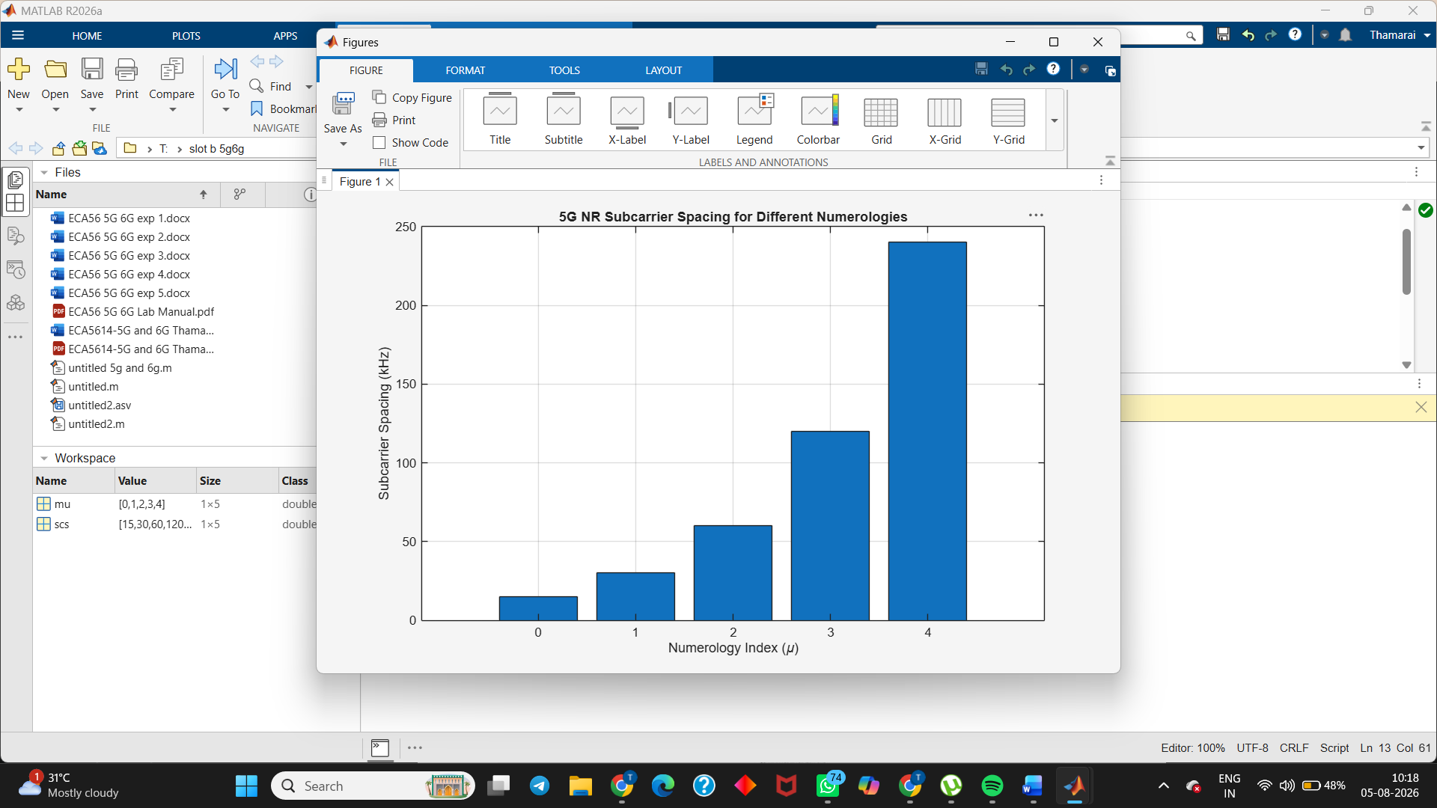
- To compare the slot duration corresponding to different Subcarrier Spacing values in 5GNR.
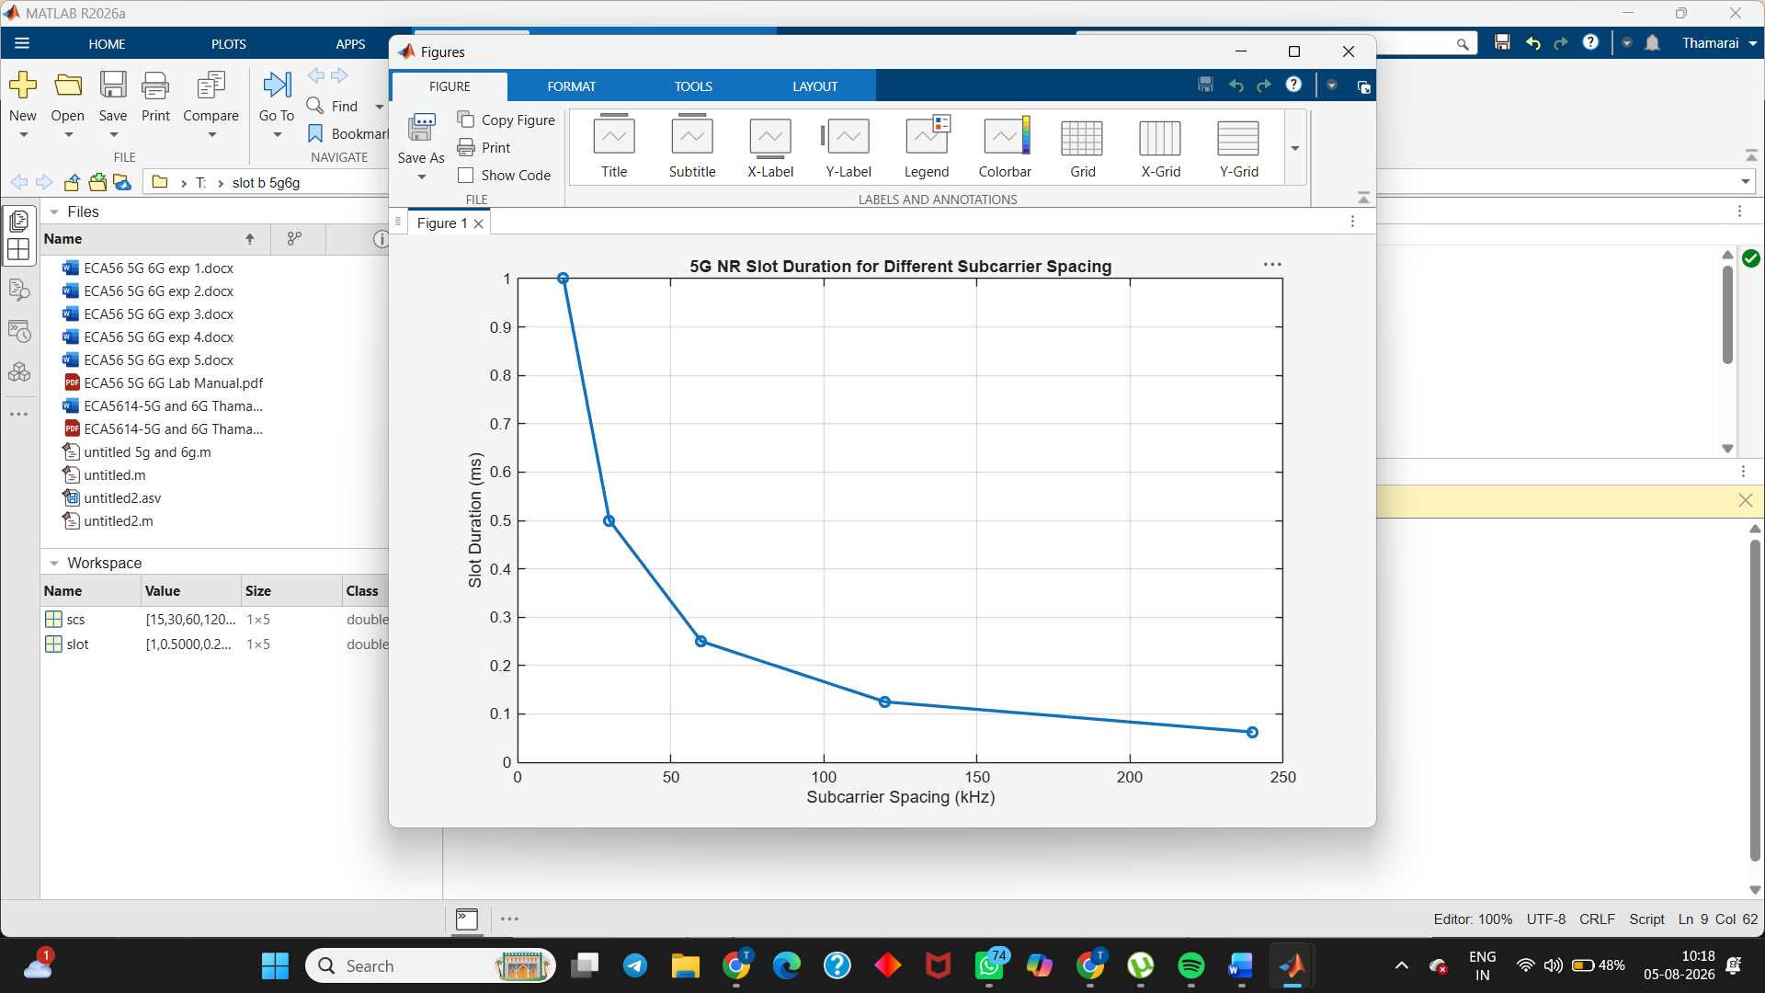
- To study the number of OFDM symbols present in a 5G NR slot for normal cyclic prefix.
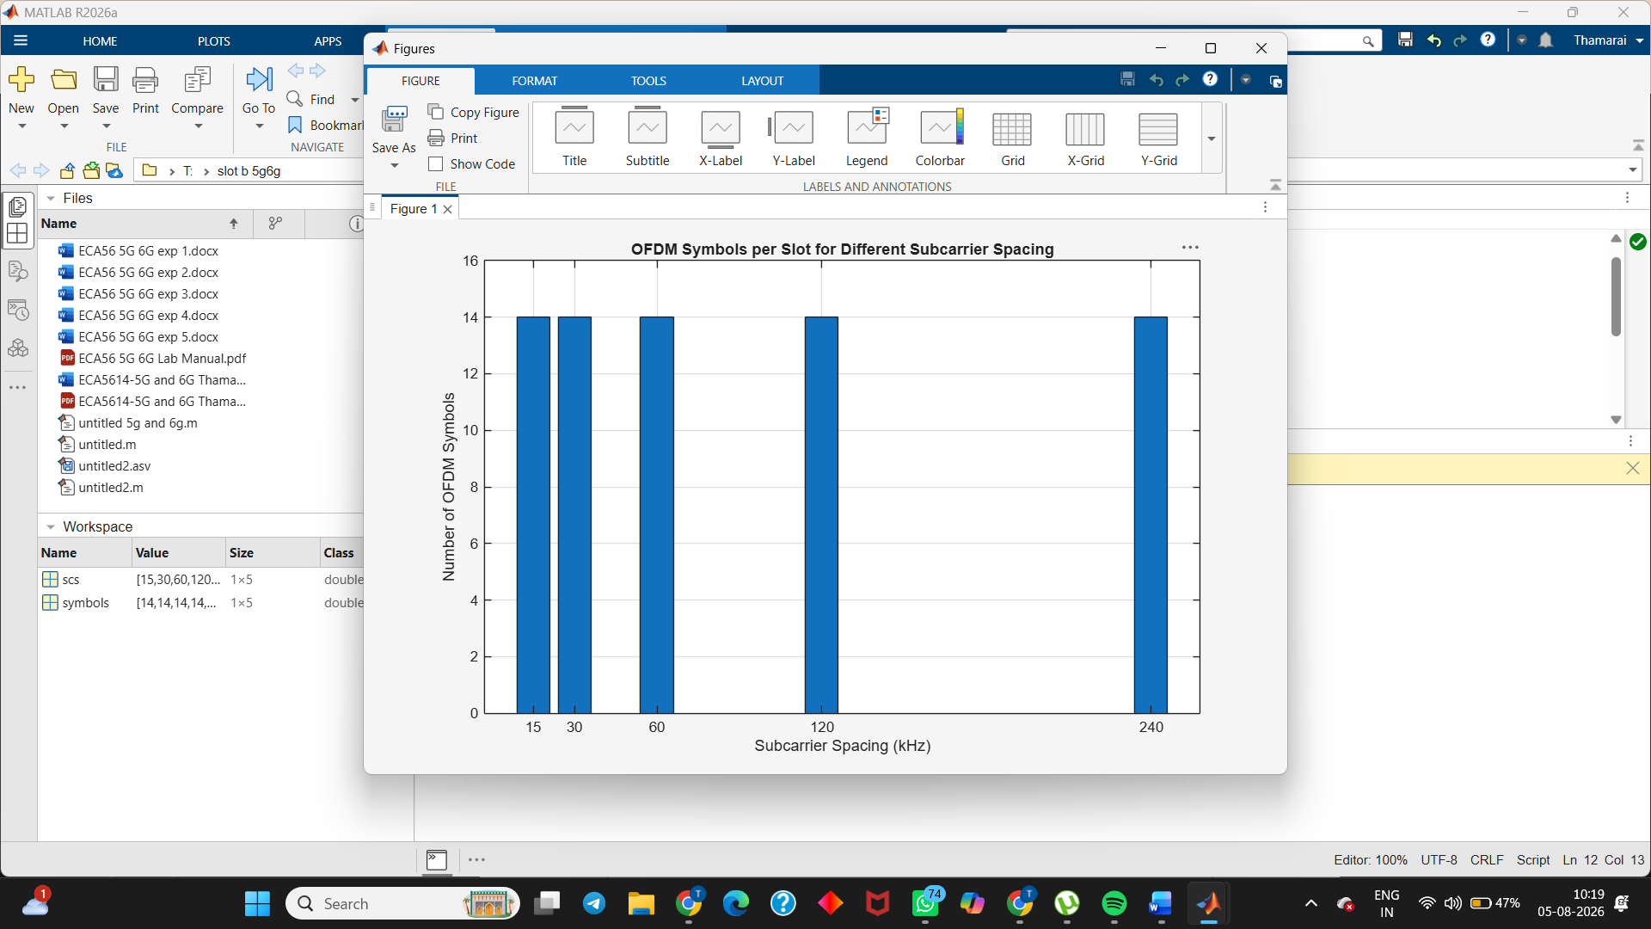

Result

The MATLAB analysis successfully demonstrated the flexible numerology of 5G NR. The results
showed that increasing the subcarrier spacing decreases the slot duration while maintaining a
constant number of OFDM symbols per slot under the normal cyclic prefix configuration.

